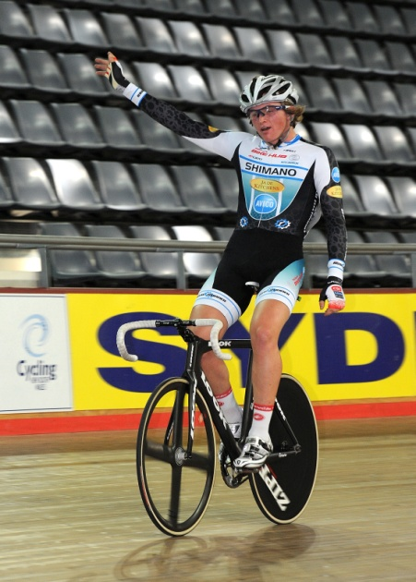**JACKSON LAW’S JUNIOR WORLD’S**

**FUNDRAISER NIGHT**

**Jackson has been selected to represent Australia at this year’s UCI Junior World Track Cycling Championships in Montichiari, Italy from the 3rd – 17th August, 2010.**

**We are having a fundraiser night at :-**

* **Fairy Meadow Surf Club, end of Elliotts Road, Fairy Meadow Beach.**
* **Saturday 5th June, 2010.**
* **6.30pm.**
* **Cost is $25-00 per adult & $10-00 per child (under 10) for buffet dinner & dessert.**

**NOTE : B.Y.O. drinks (soft drinks can be purchased on the night).**

**This is a fundraising night so bring along plenty of gold coins to toss at bottles, & plenty of notes to purchase tickets to the great raffle, lucky number draw & lucky balloons. Lots of fun & prizes to be won. So don’t forget your money.**

**For purchasing tickets, either contact**

**Grant Law – 0403368023 or Julie Law – 0403368024 or Jackson Law – 0401878659**

**Email –** [**grant@jadekitchens.com.au**](mailto:grant@jadekitchens.com.au) **or** [**julie@jadekitchens.com.au**](mailto:julie@jadekitchens.com.au) **or** [**jackson@jadekitchens.com.au**](mailto:jackson@jadekitchens.com.au)

**NOTE : SEATS ARE LIMITED, SO GET IN EARLY.**

**Payment of tickets need to be made before the night, either to anyone above or to :-**

**“Jackson’s Fundraiser Acc.” BSB 732695 & A/C No. 694582 (please put your name & surname as the reference, so we have a record of it).**

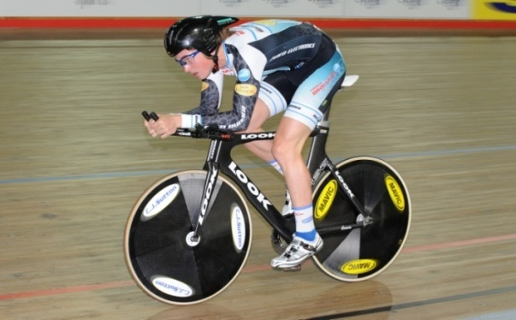 **Some of our generous supporters are :-**

**Shimano Winning Appliances**

**Fulcher’s Bike Hub Good Guys, Warrawong**

**McGee’s Cycling Store Dan Murphy bottle shop**

**Chamois Butt’r & lots more.**